A PRACTICAL GUIDE FOR COMPANIES - SETTING SITE-LEVEL WATER TARGETS INFORMED BY LOCAL CONTEXT

Contents
EXECUTIVE SUMMARY 2
ACRONYMS 3
CORE TERMS IN SETTING SITE-LEVEL WATER TARGETS 3
INTRODUCTION 6
OVERVIEW OF THE WATER TARGET SETTING APPROACH 8
STEP 1: PRIORITISE SHARED WATER CHALLENGES 11
STEP 2: DETERMINE THE DESIRED END STATE AND ANALYSE THE GAP 17
STEP 3: SET SITE-LEVEL WATER TARGETS 23
CONCLUSIONS AND RECOMMENDATIONS 26
APPENDIX 1: RELATED INITIATIVES 27
APPENDIX 2: UNPACKING CATCHMENT SCOPE WITH HYDROBASINS 28
APPENDIX 3: RESOURCES FOR STAKEHOLDER ENGAGEMENT 30
APPENDIX 4: RESOURCES TO UNDERSTAND A CATCHMENT’S WATER CHALLENGES 31
APPENDIX 5: RIVER BASIN CASED STUDIES TO DETERMINE THE END STATE AND ANALYSE THE GAP 33
APPENDIX 6: EXAMPLE SITE-LEVEL WATER TARGETS 35
ACKNOWLEDGEMENTS 37

EXECUTIVE SUMMARY
Companies, like other water users, need a reliable supply of adequate quality water. Yet, the world’s water resources are under increasing pressure from rising water consumption, pollution, and climate variability. It is important for companies to understand the factors affecting water resources in the regions where they operate as they take steps to address risks.

Water issues are primarily local – each catchment has unique hydrologic, environmental, social, cultural, regulatory, and economic characteristics. Risks to a company’s site-level access to water manifest at the local level and may be a function of a suite of issues such as: (i) access to water and sanitation, (ii) water quality, (iii) water use (iv) water governance, (iv) water-related disasters (floods and droughts).

Given that each catchment has a different set of challenges, water targets set by companies to reduce water-related risk, realize opportunities, and contribute to water security and sustainability must reflect the operating conditions at the catchment scale. Existing water targets set by companies typically focus on total water use, water efficiency, and/or water quality, but often may not address two vital questions: (i) Do these targets address the priority shared water challenge(s) for the site? (ii) Are these targets in line with the desired end state of the catchment?

This guide introduces a practical approach for companies to set targets at the site-level that reflect the local context and shared goals for improvement. It outlines a three-step process for setting water targets that address local water challenge(s) and contribute to meeting the desired end state of the basin. The three steps are: (1) prioritise shared water challenges, (2) determine the desired end state and analyse the gap, and (3) set site-level water targets (see Table 1).

Table 1. Overview of the three-step process for setting site-level water targets that reflect local context

1. Prioritise shared water challenges | 2. Determine the desired end state and analyse the gap | 3. Set site-level water targets
1.1 Understand operational risks including dependencies and impacts | 2.1 Determine the desired end state for all priority shared water challenges | 3.1 Determine site’s contribution to the desired end state for the catchment
1.2 Conduct a catchment risk assessment to determine spatial scope for target setting | 2.2 Assess the gap between the desired end state and the current state for the catchment | 3.2 Set site-level targets
1.3 Prioritise shared water challenges for the site |  | 3.3 Determine implementation strategies and measure progress
Outcome:  Develop a list of priority water challenges, related issues, and indicators (current state) | Outcome:  Understand the gap between current and desired end state for all prioritized water challenges | Outcome:  Set site-level targets and develop an implementation and measurement plan

ACRONYMS
AWS Alliance for Water Stewardship
BIER Beverage Industry Environmental Roundtable
GPCD Gallons Per Capita Daily
IAIA International Association of Impact Assessment
ICMM International Council on Mining and Metals
NGO Non-governmental organization
SARW Santa Ana River Watershed
SAWPA Santa Ana Watershed Project Authority
SBTW Science-Based Targets for Water
SDG Sustainable Development Goal
SMART Specific, Measurable, Achievable, Relevant, and Time-bound
WASH Water Access, Sanitation, and Hygiene
WRI World Resources Institute
WSP Water service provider
WWF World Wide Fund for Nature

CORE TERMS IN SETTING SITE-LEVEL WATER TARGETS
Term | Definition | Source
Baseline conditions | The beginning points at which an enterprise or activity will be monitored, and against which progress can be assessed or comparisons made. Baseline conditions establish (quantifiably / qualitatively) the status of the shared water challenges. | Adapted from:  ISEAL Code of Good Practice 2010¹
Catchment | The area of land from which all surface runoff and subsurface waters flow through a sequence of streams, rivers, aquifers and lakes into the sea or another outlet at a single river mouth, estuary or delta; and the area of water downstream affected by the site’s discharge. Catchments, as defined here, include associated groundwater areas and may include portions of water bodies (such as lakes or rivers). In different parts of the world, catchments are also referred to as watersheds or basins (or sub-basins). | AWS 2019²
Collective action | Collective action is coordinated engagement among interested parties within an agreed-upon process in support of common objectives. Water-related collective action refers to efforts specifically to advance sustainable water management, whether through encouraging reduced water use, improved water governance, pollution reduction, river restoration, or other efforts. | CEO Water Mandate 2013³
Contribution | The company’s proportionate responsibility towards the desired end state of a shared water challenge in a given catchment. Contributions should be informed by proportional impacts/risk exposure, capacity, and what is required to reduce risk and achieve the desired end state. | Reference the current document
Desired end state | The strategic goal relating to the reduction or elimination of a shared water challenge within a given catchment. | Reference the current document
Goal | A description of a desired end against which the company and its stakeholders can evaluate company progress. | CEO Water Mandate 2014⁴
Impacts | The long-term social, economic, and environmental effects resulting from the implementation of company activities, either directly or indirectly, intended or unintended. The impacts can be positive (those impacts that generally benefit stakeholders) or negative (those impacts which are generally harmful to stakeholders). | Adapted from:  ISEAL Code of Good Practice 2010¹ and  IAIA⁵
Water risk | The possibility of a company experiencing a water-related challenge (e.g., water scarcity, water stress, flooding, infrastructure decay, drought). The extent of risk is a function of the likelihood of a specific challenge occurring and the severity of the challenge’s impact. The severity of impact itself depends on the intensity of the challenge, as well as the vulnerability of the actor. | CEO Water Mandate 2014⁴
Water stewardship | The use of water that is socially equitable, environmentally sustainable and economically beneficial, achieved through a stakeholder-inclusive process that includes both site- and catchment-based actions. | AWS 2019⁶
Shared water challenge | The water-related issues that are of interest or concern to both the site and to other stakeholders in the catchment and which, if addressed, would provide positive impacts or prevent negative impacts. | AWS 2019²
Site | The physical area over which the company owns or manages land/facility and carries out its principal activities. Where the organization operates its own water sources and/or wastewater plant, these should also be considered part of the ‘site.’ For example, for a bottled water factory that operates a physically separate water source (e.g., spring or borehole), this should be considered part of the ‘site.’ | AWS 2019²
Site-level target that reflects the catchment context | A desired result (often expressed numerically) that is the function of one or more activities undertaken by the site over a specified time period. It describes the site’s contributions to the desired end state of the catchment. | Reference the current document
Sustainable Development Goals (SDGs) | Officially known as “Transforming our World: the 2030 Agenda for Sustainable Development,” is a set of 17 “Global Goals” with 169 targets among them. Spearheaded by the United Nations through a deliberative process involving its 193 Member States, as well as global civil society, the goals are contained in paragraph 54 United Nations Resolution A/RES/70/1 of 25 September 2015. | United Nations Sustainable Development Goals⁷
Threshold | The point at which a relatively small change or disturbance causes a rapid change in a system. When a threshold has been passed, the system may no longer be able to return to its state by means of its inherent resilience. For example, when an ecological threshold is crossed it often leads to a rapid change of ecosystem health. Ecological thresholds represent the non-linearity of responses in ecological or biological systems to pressures caused by human activities or natural processes. | Groffman et. al. 20068
Water governance | The political, social, economic, and administrative systems that are in place, and which directly or indirectly affect the use, development, and management of water resources and the delivery of water service at all levels of society. | Adapted from:  Water Governance Facility⁹
Water security | The capacity of a population to safeguard sustainable access to adequate quantities of acceptable quality water for sustaining livelihoods, human wellbeing, and socio-economic development, for ensuring protection against waterborne pollution and water-related disasters, and for preserving ecosystems in a climate of peace and political stability. | UN Water 2013¹⁰
¹ ISEAL Code of Good Practice. 2010. Setting Social and Environmental Standards v5.0. ISEAL Alliance. https://www.isealalliance.org/sites/default/files/resource/2017-11/ISEAL_Standard_Setting_Code_v6_Dec_2014.pdf
² AWS. 2019. The AWS International Water Stewardship Standard v2.0.
³ CEO Water Mandate. 2013. Guide to Water-Related Collective Action. https://ceowatermandate.org/wp-content/uploads/2013/09/guide-to-water-related-ca-web-091213.pdf
⁴ CEO Water Mandate. 2014. Corporate Water Disclosure Guidelines. https://ceowatermandate.org/disclosure/
⁵ IAIA. https://www.iaia.org/about.php
⁶ AWS website. https://a4ws.org/about/
⁷ The UN Sustainable Development Goal website provides information on each of the 17 Goals including associated targets and indicators. https://www.un.org/sustainabledevelopment/sustainable-development-goals/
⁸ Goodman, I.; Gunderson, L.H.; Levinson, B.M.; Palmer, M.A.; Paerl, H.W.; Peterson, G.D.; Poff, N.L.; Rejeski, D.W.; Reynolds, J.F.; Turner, M.G.; Weathers, K.C. and J. Wiens. 2006. Ecological Thresholds: The Key to Successful Environmental Management or an Important Concept with No Practical Application? Ecosystems, 9: 1–13. http://landscape.zoology.wisc.edu/People/Turner/groffman2006ecosys.pdf
⁹ Water Governance Facility. http://www.watergovernance.org/water-governance/
¹⁰ UN Water. 2013. Water Security & the Global Water Agenda, A UN-Water Analytical Brief, October 2013. http://www.unwater.org/publications/water-security-global-water-agenda/

INTRODUCTION
Freshwater is a finite shared resource with high social, cultural, environmental, and economic value. Many companies are dependent on reliable access to an adequate supply of water that is of acceptable quality for their operations. Yet, the world’s water resources are under increasing pressure from rising water consumption, pollution, and greater climate variability (Box 1), exposing companies to increased water-related risks (Figure 1). A growing number of companies have acknowledged the potential exposure to water challenges, with water crises ranked as one of the top ﬁve global risks annually since 2012.

Box 1. Water crisis trends relevant to all water users including companies
- An estimated 2.1 billion people worldwide lack access to safe drinking water and 4.5 billion people lack safely managed sanitation services.
- Globally, eighty percent of wastewater generated flows back into ecosystems without being treated or reused, putting the 18 million people using contaminated drinking water at risk of contracting cholera, dysentery, typhoid, and polio.
- Global demand for water is predicted to increase by fifty-five percent between 2000 and 2050.
- Poor resource management, corruption, inappropriate institutional arrangements, bureaucratic inertia, insufficient human capacity, and limited investments undermine effective water governance.
- Freshwater species have declined with one index showing an eighty-three percent decline since 1970.
- Due to climate change, there will be higher temperatures and more extreme weather conditions altering water availability, timing, quality, and demand. More floods and drought are predicted, leading to greater economic costs and human health impacts.

Figure 1: Top 5 risk drivers and water-related risks disclosed by companies to CDP in 2017

Water challenges manifest themselves locally. Water challenges are global in scope. Yet, they manifest themselves locally due to each catchment’s unique hydrologic, environmental, social, cultural, regulatory, and economic characteristics. The shared nature of water challenges calls for interventions across all stakeholders, accounting for the catchment-specific needs, to meaningfully reduce site-level risk.,, Accordingly, site-level targets that account for local context are more likely to reduce risk exposure and improve catchment water security.
Box 2. Current corporate water target setting practice
CDP’s 2018 water questionnaire asked companies to describe their approach to setting water-related targets and/or goals. The data for approximately 800 company respondents showed:
- Sixty-five percent have water-related targets/goals.
- Thirty percent have goals set at the company and site-levels, a promising movement towards targets that account for local context.
- Only five percent have goals at the three different levels: (i) company-wide, (ii) catchment-level, and (iii) site-level.
To date, companies’ consideration of local catchment conditions in target setting has been limited. In 2018, about sixty-five percent of companies reporting to CDP had water-related targets; but only one-third of the reporting companies had site or catchment-level water targets that account for local context (Box 2). Water targets are typically focused on total water use, water efficiency, and/or water quality, and may ignore other water challenges, such as WASH, and may not contribute to the relevant local water challenges.

This guide introduces a practical three-step approach for companies to set site-level water targets that:
- Align with the priority shared water challenges within the catchment;
- Reflect the site’s relative contribution to the shared water challenge(s) and desired end state; and
- Support company efforts to reduce exposure to water risk, capitalise on opportunities, and contribute to overall catchment-level water security.

OVERVIEW OF THE WATER TARGET SETTING APPROACH
This guide supports companies in setting site-level water targets that are informed by local context.
The approach was developed through research on catchment water resources management and pilot testing in various countries. It was also reviewed by a multi-sectoral stakeholder group.

The approach was developed with the following success criteria to optimise its utility and application for companies. The objectives of the guide are to be:
- Directionally correct to incentivise the right behavior across a company’s sites and to align with the desired end state of the catchment;
- Relevant at any given geographic location;
- Applicable to any sized company, in any industry sector; for companies at different stages of the water stewardship journey; and for different types of sites (e.g., manufacturing, farms, retail space, etc.);
- Applicable for a broad set of water-related challenges;
- Practical for company decision-making; and
- Informed by the best available science, policy objectives, and leading practice.

The approach aims to complement existing initiatives and guidance as summarized in Appendix 1. Appendix 3-6 provide tools and resources for each step of the approach.

The guide is intended for two principal audiences:
- Site level: site managers or technical water specialists responsible for the management and oversight of water.
- Corporate level: corporate managers with technical or functional responsibility for corporate/business unit management of water issues, and/or for establishing and meeting enterprise level water targets.

To ensure global alignment and applicability, this guide has been informed by and cross-referenced to the Sustainable Development Goals (SDGs), which also broadly align to the five water stewardship outcomes identified by AWS., The guide is oriented around the SDGs and associated water challenges shown in Table 2.

Table 2. SDGs and associated shared water challenges that inform the target setting approach

SDG | Shared Water Challenge | Existing Indicators
WASH (SDG 6.1 and 6.2) | People and communities lack sufficient access to safe and affordable drinking water, sanitation, and hygiene. | % population using safely managed drinking water services  % population using safely managed sanitation services
Water quality (SDG 6.3) | Water that presents health threats to humans and/or the environment. Water that is unfit for its intended use due to quality impairments. | % wastewater safely treated  % bodies of water with good ambient water quality
Water quantity (SDG 6.4) | Demand (human and environmental) for water exceeds the available supply indicating water resources are out of balance.  There is an imbalance between the volume of water available and the volume of water demanded (too much or too little water). | Change in water-use efficiency over time  Freshwater withdrawal as a proportion of available freshwater resources
Water governance  (SDG 6.5) | The political, social, economic, and administrative systems which affect the use, development, and management of water resources are ineffectual, corrupt, underfunded, or otherwise inadequate. | Degree of integrated water resources management implementation
Important water-related ecosystems (SDG 6.6) | Water-related areas of environmental, cultural, and spiritual significance are degraded and there is a loss of freshwater ecosystems. | Change in the extent of water-related ecosystems over time
Extreme weather events (SDG 11.5 and 13.1) | People and communities are at risk of catastrophic impacts due to extreme water-related weather events such as droughts and floods. The frequency and intensity of these events are increasing due to climate change. | Number of deaths, missing persons and directly affected persons attributed to disasters per 100,000 population  Direct economic loss in relation to global GDP, damage to critical infrastructure and number of disruptions to basic services, attributed to disasters

This guide is not intended to be prescriptive, or a technical handbook detailing methods to quantify numerical values for the catchment limits if they have not yet been established. However, in the absence of those estimates sites can establish directionally correct targets. The Science-Based Targets for Water intends to develop an approach to understand the catchment limits (Appendix 1).

This guide does not require companies to go through certification and verification but complements the Alliance for Water Stewardship (AWS) standard which does. AWS is broader than just target setting but the results from this guide can be used for AWS and vice versa. This guide does not require companies to publicly communicate, report, or commit to the targets although it is highly encouraged.

Finally, the guide is not linear but iterative. For example, once the water challenges are assessed, it is important for the site to re-evaluate the catchment’s spatial scope. The site should also re-assess the entire process every few years because the desired end state may change due to climate change impacts and changes in water conditions. Similarly, the targets should be reassessed every few years to ensure they reflect the priorities of the site and catchment. While stakeholder engagement is important for all steps, detailed guidance is not provided in the text considering good practice on the topic is already well covered (see also Appendix 3)., The next three chapters are the heart of the guide and describes in detail the three steps and corresponding sub-steps for setting site-level targets.

STEP 1: PRIORITISE SHARED WATER CHALLENGES
Determining the spatial scope for consideration of shared water challenges is a function of two key water risk factors:

- Operational water risk is dictated by the nature of the site’s operations (i.e., its dependence and impact on water resources); and
- Catchment water risk is dictated by the location of the site, source catchment(s), and wastewater discharge locations.

The priority water challenges facing the site can be identified by considering the risk levels for each water challenge at the operational and catchment scale (Figure 2).

The guidance for Step 1 below outlines three sub-steps, which helps the Site Manager/ Representative to understand operational risks, determine the spatial scope, and screen for the six shared water challenges.
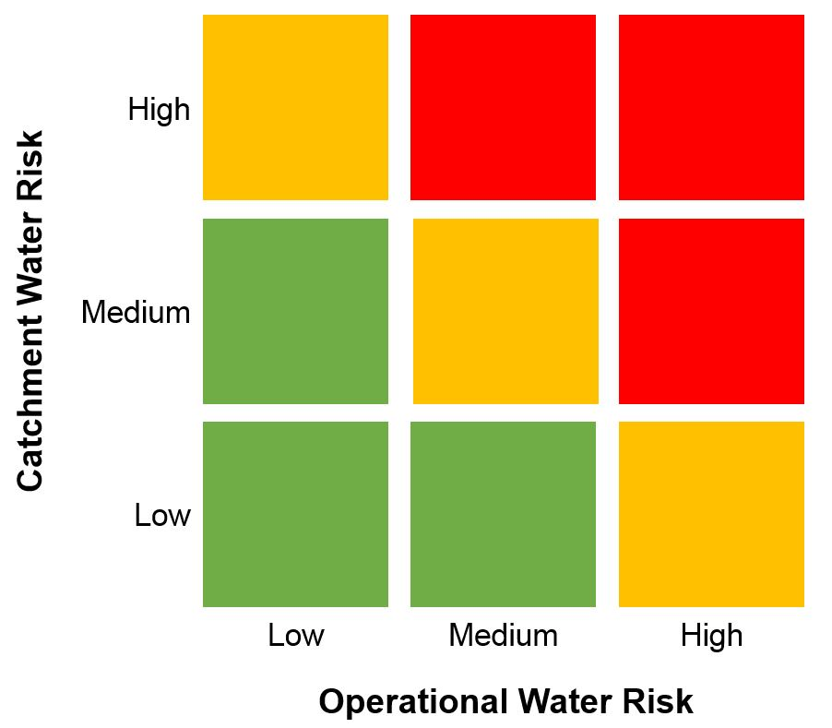

Figure 2: Combine operational and catchment risk to identify the site’s priority water challenges

1.1: Understand operational risks including dependencies and impacts
Understanding the site’s operational risks helps to provide an understanding of the material issues. Different sites may face different risks from the same water challenges, due to the nature of their operations. For each water challenge, two primary operational risk-related questions should be asked to assess the site’s dependence and impact on the catchment:

- Dependencies: To what extent is the site likely to be affected by the water challenges because of its dependencies on water?

  - Example: An almond tree is a permanent crop that requires water every year. Groundwater overdraft due to excessive withdrawals by all water users poses a major risk to this almond orchard, potentially requiring the farmer to drill a deeper well, find another source of water, or severely underirrigate, reducing their returns and potentially harming long-term viability.

- Impacts: To what extent do the operations of this site contribute to water challenges, especially for others?

  - Example: A thermoelectric power plant discharges water that is a significantly warmer than the ambient temperature of the stream to which it is discharging. This could have an adverse impact on the health of downstream aquatic species and poses regulatory and reputational risks to the plant.

While a quantitative approach to operational risk is possible, a more qualitative approach may suffice (high/low risk).

1.2 Conduct a catchment risk assessment to determine the spatial scope for target setting
The spatial scope should include the site’s physical boundary, and the area of influence of the site’s source water (e.g., local surface water, groundwater, and imported water) and water discharge. The scope should include the areas on which the site depends as well the areas that the site impacts. In some cases, this might include multiple catchments. See Figure 3 for an illustrative example of a water catchment.

Figure 3. An illustrative example of a water catchment
Some or all of the following information should be gathered to determine the most appropriate spatial scope for analysis, with catchment information being particularly critical:

- The site’s owned or managed property boundaries;
- Water-related infrastructure (e.g., pumps, pipes, reservoirs) owned or managed by the site or its parent organisation in connection to the site;
- Any water sources providing water to the site that is owned or managed by the site or its parent organization;
- The site’s water service provider, if applicable;
- Discharge points and wastewater service provider, if applicable, and the receiving water body or bodies; and
- Catchment(s) and/or groundwater aquifer(s) that the site impacts and/or depends on for water.
(Note: This sub-step is similar to criterion 1.1 of the AWS Standard - Gather information to define the site’s physical scope for water stewardship purposes).

Defining the appropriate spatial scope is challenging and there is no perfect answer. Since catchments vary in size from smaller (e.g., tributary of the Manu) to very large (e.g., Amazon River Basin), the spatial scope should be large enough to capture relevant issues but not so large as to be unmanageable. At one extreme (e.g., the site), the size is too small to account for all impacts and dependencies, while at the other extreme (e.g., continental-scale basin), the size is too large to be practical to manage. We recommend using the same catchment boundaries as the water governing body (e.g. Catchment Authority or Water Board). If that is unavailable, an alternative could be used (see Appendix 2).

A range of spatial scales for the scope should be employed based on the water challenge under consideration —the key is to be transparent about assumptions. For example, when considering WASH, conditions should ideally be assessed across the entire catchment because WASH is such an acute issue for human health and dignity, but the scope of the assessment may need to be narrowed for practical purposes or enlarged depending on the site’s circumstances. Similarly, water may be sourced locally (e.g., a local aquifer), or from far away (e.g., long-distance inter-basin transfers), affecting the scope. Table 3 lays out examples and suggested considerations for scoping each of the six shared water challenges.

Table 3: Illustrative examples for the determination of spatial scope for target setting
Challenge | Physical Boundary (suggested) | Considerations
WASH | - The approximate area in which site employees live  - Municipality or county | - Distance site employees travel to work.
Water Quality | - HydroBASIN level 6 to level 9 (See Appendix 2)  - Underlying groundwater catchment (if applicable) | - Is incoming water quality important to the site’s operations? If so, then include upstream areas (or groundwater catchment areas) that affect incoming water quality.  - Does the site discharge (including run-off) directly to water bodies? If so, then include downstream areas that may be affected by discharges (including due to cumulative impacts).
Water Quantity | - HydroBASIN level 6 to level 9 (See Appendix 2)  - Underlying groundwater catchment (if applicable) | - Is water availability important to the site’s operations? If so, include upstream areas (or groundwater basin areas that affect flow/recharge to the site’s primary water suppl(ies).  - Does the site consume significant amounts of water? If so, then include downstream areas that may be affected by lower flows due to withdrawals at the site.
Water Governance | - Basin authority area, municipality, state/province | - At what scale are important water-related management decisions made (allocations, rules and regulation, planning, etc.) that affect the site? Local? State? Federal?
Important Water-Related Ecosystems | - HydroBASIN level 6 to level 9 (see Appendix 2) | - If water quality or quantity are important to the site, then upstream and downstream green infrastructure should be accounted for. Similarly, if extreme weather events are of concern, ecosystem areas upstream and downstream become more material.  - Locations of wetlands of international importance and/or habitats with species with high conservation status.,  - Locations of any significant water-related sites with cultural and/or spiritual significance.
Extreme Weather Events | - HydroBASIN level 6 to level 9 (see Appendix 2) | - Does the site rely on imported water sources and related infrastructure that may be vulnerable to extreme events?  - Is the site or any water infrastructure vulnerable to flood risks?  - Based on its dependencies, is the site vulnerable to drought?

1.3 Prioritise shared water challenges for the site
After identifying and assessing the site’s spatial scope, the next component is to understand the water challenges facing the catchment(s) relevant to the site. Wherever possible, it is recommended that data is gathered from local sources (e.g., local reports, data sets, knowledge from staff and other local stakeholders) to evaluate each water challenge. If local resources are not available, global models and tools, such as World Resources Institute’s (WRI’s) Aqueduct and WWF’s Water Risk Filter, can be used. However, relying on global models may result in a lack of accuracy and granularity (spatial, temporal, and thematic) in understanding key water challenges. It is therefore important to check the results of the global models with local experts to ensure no critical challenges were missed. For Aqueduct and the Water Risk Filter, we recommend focusing on those areas with water risk score of “3” or higher (1 being lowest risk, 5 being highest).

Understanding water context can be difficult without adequate resources, expertise, and information. A site’s capacity to undertake the analysis will often depend on access to internal and external water expertise. Table 4 provides a general guide for the level of resources and capacity needed to do a robust contextual assessment.

Table 4. Resources for assessment of shared water challenges
Assessment | Activities Involved | Level of Resources Needed | Recommended Capacity | Recommended Resources and Stakeholders to Engage
Local screening of water challenges (recommended) | For each material water challenge, gather local data and information about the current status of those challenges in the relevant catchment(s). | Medium | - Internal – advanced site or regional level water engineer or subject matter expert  - Internal – corporate sustainability or water stewardship expert  - External – corporate water stewardship expert (consultancies, NGOs, etc.) | - Municipal, regional, state, or national public water databases and water management plans  - Local academic water research  - Local stakeholder groups
Coarse screening of water challenges | Use online global assessment tools or basic screen template (Appendix 4) to identify material water challenges if local data and information is not available.  Check with experts/stakeholders to ensure no key challenges are missed. | Low | Internal – advanced site or corporate level | - National public water databases  - Global tools & models (WWF Water Risk Filter, WRI Aqueduct)  - Local staff

Using the relevant catchments and regions identified, the site should assess the shared water challenges within the spatial scope to identify all material water challenges out of the six outlined in Table 2. To understand the detail of the operating context, it is recommended that metrics and data for each water challenge identified be evaluated using local/regional data and information. When analysing water challenges for catchment(s) with multiple sites, sub-catchment metrics and data should be collected that show variation within each catchment. A complete list of resources for this analysis can be found in Appendix 3-6 and an example can be found in Box 3.
Box 3. Illustrative example of the process used to identify priority water challenges in the Santa Ana River Watershed (SARW) in California, USA
Step 1.1: In the SARW pilot testing of this guide, a survey was sent to each site and subsequent conversations determined which water catchments and service providers the site depended on and impacted. Impacts and dependencies varied site by site.
Step 1.2: The following process was used to identify priority water challenges at the local level:
- Reviewed water service provider (WSP) planning documents to understand all water sources (local and imported) and assess current and anticipated water challenges in the source catchments.
  - Sites participating in the pilot were predominantly serviced by water utilities and/or water wholesalers whose jurisdictions encompassed a single municipality or a handful of municipalities. Sites were encouraged to read the urban water management plan of their WSP, as each WSP within the catchment faces slightly different challenges.
- Reviewed local catchment management plan and associated governance documents to understand the regional water context.
- Engaged internal and external stakeholders to vet and verify priorities identified.
  - For this pilot, the CEO Water Mandate convened participating companies with a representative from the Santa Ana Watershed Project Authority (SAWPA) to discuss perspectives on key water-related risks.

Step 1.3: Finally, the CEO Water Mandate, in consultation with the pilot testers, developed an initial list of priority water challenges and associated metrics (top three outlined below).

Water Challenge | Key Issues (and metrics)
Water quantity | Rapid urbanization and population growth (water depletion)
 | Reliance on imported water, including for groundwater recharge (water supply portfolio)
 | Wasteful/excessive water use (daily per capita water use)
Water quality | Surface water contamination (streams federally listed as impaired)
 | Groundwater contamination (well samples that exceed Maximum Contaminant Levels)
Extreme Water-Related Events | Climate change exacerbating hydrologic extremes (variability in precipitation patterns)

Before moving on to Step 2, it is worth reviewing Step 1. Identifying the right issues, in the right places, may require an iterative process. For example, in consulting with local experts a site may learn that there was a major flood 30 years ago that affected the local region, and this was a function of logging in the upper source catchment that was originally out of scope. Adjusting the catchment scope to include this area would also indicate that ecosystems should be included in the thematic scope and included in the target-setting exercise.

STEP 2: DETERMINE THE DESIRED END STATE AND ANALYSE THE GAP
Step 2 of this target-setting process establishes the catchment desired end state for the priority water challenges selected in Step 1, and identifies the gap between the desired end state and the current catchment state/condition. The current state is encompassed by the priority water challenges that were identified in Step 1. This assessment provides additional, needed context for setting appropriate targets.

2.1 Determine the desired end state for all shared priority water challenges
The desired end state is the strategic goal pertaining to the reduction or elimination of a shared water challenge within a given catchment. It helps answer the question: what does success look like for the catchment? Depending on the nature of the challenge and availability of data, the end state assessments may be qualitative and/or quantitative (see Box 4).

Box 4. Qualitative and quantitative examples of desired end state for priority water challenges

Qualitative descriptions can help paint the picture of how stakeholders envision the improved future conditions. These qualitative descriptions can be supported by measurable metrics related to the priority water challenges to help clearly distinguish between current conditions and a preferred end state and to provide a way to measure progress along the way.

  - For example, for a river or stream segment of interest, if during July native fish are dying due to high temperatures, reduced vegetation along the stream, and/or discharge of high temperature water into the stream, the qualitative desired end state may be ”a critical stretch of river where temperature-related fish kills in the peak of summer are avoided.”

- Quantitative descriptions can focus on numerical or otherwise tangible values that allow for measurement of progress towards a target over time.

  - For example, for the same river or stream segment described above, the quantitative desired end state may be “a critical stretch of river with an average July temperature of 21 degrees Celsius.” This quantitative end state could help in target setting and could also be used as an input in a stream modeling tool when designing solutions.

To determine the desired end state for the priority shared water challenges(s) or SDG6 target categories (Table 2), companies should leverage, where available, existing information provided by organisations managing shared water resources at a catchment, state/province, or national level. This could be from a catchment commission; water utility; surface or groundwater board, or organization with similar mandate; or national or local (state, province, or county) water regulatory agencies. The types of information used to describe the desired end state include water resources management plans and documents that capture a collective understanding of stakeholder priorities. Water management plans look towards the future and therefore are a better resource for understanding the desired end state than permitting requirements. which may not be based on the desired end state.

Table 5. Resources for end state determination and gap analysis of water challenges

Assessment | Activities Involved | Level of Resources Needed | Recommended Capacity | Recommended Resources and Stakeholders to Engage
Desired end state determination | For each priority water challenge, establish the desired end state at the catchment scale. | Medium | • Internal – regional level subject matter expert  • Internal – corporate level hydrologists/water stewardship experts  • External – hydrologists/corporate water stewardship expert (consultancies, NGOs, academics, etc.) | • Catchment-level data and hydrologic models  • Catchment-level water management plans  • Local stakeholder groups (river basin organizations, natural resource management agencies, other water users, etc.)
Gap analysis of water challenges | For each priority water challenge, assess / estimate the gap between the current condition and the desired end state. | Medium to high | • Internal – regional level subject matter expert  • Internal – corporate level hydrologists/water stewardship experts  • External – hydrologists/corporate water stewardship expert (consultancies, NGOs, academics, etc.) | • Catchment-level data and hydrologic models  • Catchment-level water management plans

If there are no existing documents that capture the desired end state according to a relevant organisation or collection of stakeholders, the company should develop a desired end state based on other available information and conversations with experts or key stakeholders about their vision for a sustainable water future. For some challenges, the desired end state will be relatively straightforward. For example, for water quantity of a stream, the desired end state may be to meet all the water user needs, including environmental flow needs, for all seasons. For water quality, the desired end state may be for a stream to meet specific water quality standards established by a relevant agency for pollutants of concern.

2.2 Assess the gap between the desired end state and the current state for the catchment
Once the company and its partners agree on the desired end state of the catchment for the priority water challenges, the gap between the two states should be determined. This will help the company understand the magnitude of the problem, which will inform the expected timeline and scale of solutions required to achieve the desired end state. Most likely, collaboration with other stakeholders (i.e., through collective action) will be needed to achieve the desired end state. Understanding this gap for multiple high priority water challenges may also help the company further prioritize the challenges, providing insight into which one(s) to tackle first (see Appendix 5 for a list of case studies). The types of information and recommended capacity for the gap assessment is very similar to those describe for the desired end state (see Table 5).

If data are available, it is recommended that the gap for each water challenge be quantitatively assessed as it sets the foundation for more precise water targets for the catchment. Table 6 provides an example of how a site might quantitatively and qualitatively assess the gap for each water challenge. The assessment does not need to be absolutely correct, rather it is about being directionally correct.

Table 6. Illustrative examples of gap assessments for each shared water challenge
Shared Water Challenge | Metric | Baseline Conditions | Desired End State | Gap
WASH | People with access to clean water and/or improved sanitation | 50% of employees and community members have access to improved sanitation. | All employees and community members have access to improved sanitation. | Additional 50% of employees and community members have access to sanitation.
Water quality | Nutrients | Nutrient levels (nitrogen and phosphorus) are causing algal blooms, oxygen depletion, fish kills or illness on at least an annual basis. | Nutrient levels in local freshwater bodies are consistently below 'safe' standards and do not cause any related problems to fish or people. | The difference in annual nutrient loading between the current state and safe standards level.
 | Wastewater discharge | 50% of wastewater is safely treated. | 100% of wastewater is safely treated. | Additional 50% of wastewater need to be safely treated.
Water quantity | Local surface and groundwater resources | Surface and groundwater water withdrawals is greater than the renewable supplies for sources where the company and other water users depend on. | Surface and groundwater water withdrawals are in line with the renewable supplies. Aquifer levels are stabilized. | The difference between the current water use from surface and groundwater and sustainable levels of water use (use is equal to or less than the local renewable supplies).
Water governance | Government coordination and policy coherence | No communication or alignment between different government sectors on policy, planning and management. | Effective coordination between government authorities responsible for water management and those responsible for other relevant sectors. | The qualitative gap in communication and coordination of water authorities, which could include missing lines of communication, platform for collaboration or staff who can lead the coordination.
 | Data and information for decision-making | Very limited quantitative information on water availability, demand and water quality in existence or publicly available. | Robust data and information on water availability, demand and water quality freely accessible to inform decision-making. | The qualitative gap in water related data, including on water levels and flows, regular water quality measurements of key water bodies, and measurements of water use.
Important water related ecosystems | High value water bodies | Impaired water bodies with little appropriate management interventions. | Water bodies are in good condition with management measures in place to protect their status. | The difference in the conditions of water bodies due to land use change, reduced environmental flow, increases water pollution.
Extreme weather events | Improve climate change resilience | Significant economic loss due to extreme weather events with no disaster risk management plans in place. | Low economic loss due to extreme weather events with robust disaster risk management plans in place. | The difference in economic loss due to lack of preparation and an adequate disaster risk management plan.

A second option for this gap assessment is using a ‘stoplight’ approach. Below is an example of this approach applied at a target-setting pilot project in the Santa Ana River Watershed in California, USA. Each color – red, orange, yellow, and green - is determined by a quantitative threshold.

Box 5. Stoplight approach used to assess the gap for priority shared water challenges in the Santa Ana Catchment, California

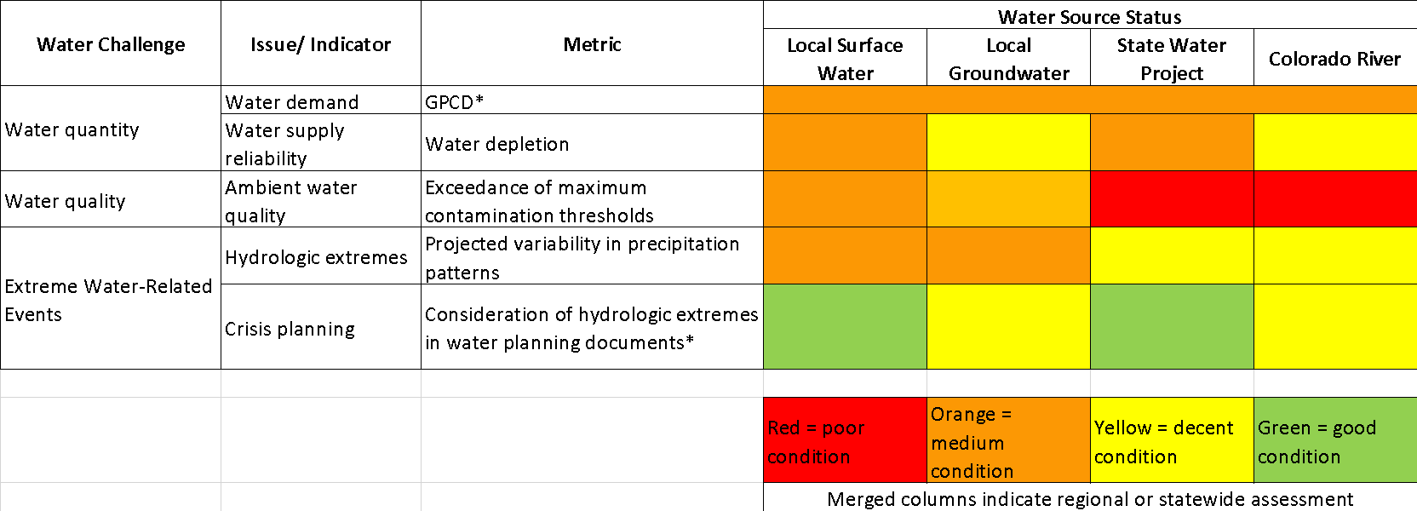
*GPCD: Gallon Per Capita Daily

In most cases, assessing the water governance gap quantitatively is not possible and may not be necessary in order to set a meaningful governance target as the examples in Table 6 show. For water governance, the degree of water resources management implementation (i.e., SDG 6.5.1), provides a useful framework for understanding the key components of water governance and the desired states underpinning effective water governance and management (see Table 7). The categories for water governance range from poor, moderate, and good-excellent, is a qualitative gap assessment between the current conditions and the desired end state.

Table 7. Illustrative examples of desired end states and gap assessment for water governance
Water Governance | Progress Towards the End State
 | Poor | Moderate | Good – Excellent
Water resource policy and regulation | Water policy and regulations exist, although not based on principles of equity or sustainability nor enforced. | Adequate – effective water policy and regulations in place with inconsistent enforcement. | Effective and equitable water resource policy and regulation in place and being enforced.
Government coordination and policy coherence | No communication or alignment between different government sectors on policy, planning, and management. | Opportunities for different government sectors to take part in policy, planning and management processes. | Effective coordination between government authorities responsible for water management and those responsible for other relevant sectors
Basin management plans | Basin plan does not exist, is being prepared, or is very outdated. | Basin plan approved, and implementation by relevant authorities commenced. | Robust basin plan in place, its objectives consistently achieved, and periodically reviewed and revised.
Capacity of basin institutions | No dedicated government authorities for basin water resources management. | Basin authority(s) have a clear mandate, the capacity to effectively lead plan formulation but inadequate capacity for full implementation of the plan. | Authorities have the capacity to effectively lead implementation and periodic monitoring, evaluation and revision of the basin/water resource management plan.
Public participation | No communication between government and stakeholders on policy, planning and management. | Government authorities occasionally request information, experiences and opinions of stakeholders. | Regular (formalized) opportunities for stakeholders to take part in relevant local level policy, planning and management processes.
Monitoring and evaluation of water resources | No-limited monitoring (surface and groundwater) is carried out. | Some monitoring (surface and groundwater) is carried out with ad-hoc coverage and/or continuity. | Long-term monitoring (surface and groundwater) is carried out with very good coverage and use by stakeholders.
Data and information for decision-making | Very limited quantitative information on water availability, demand and water quality in existence or publicly available. | Some quantitative information on water availability, demand and water quality available although not necessarily public. | Robust data and information on water availability, demand and water quality freely accessible to inform decision-making.
Performance of water supply and treatment infrastructure | Business and/or local community regularly experience intermittent supply of water and / or inadequate treatment of wastewater. | Occasional minor-moderate level performance issues experienced with water supply and/or treatment. | Water provision and treatment infrastructure/services reliable, with good coverage and to a high standard.

STEP 3: SET SITE-LEVEL WATER TARGETS
Step 3 determines the site’s contribution to the desired end state, sets site-level targets, determines implementation strategies, and measures progress towards those targets.

3.1 Determine the site’s contribution to the desired end state for the catchment
Once the gap between the current and desired end state for priority shared water challenge(s) has been established, the site can then determine its contribution to meeting the desired end state and in turn inform the target(s) it sets. The site’s contribution refers to the site’s proportional responsibility towards the desired end state of a shared water challenge in a given catchment. The site’s contribution should be informed by the site’s impact and dependency (Step 1.1) on the water resources relative to other water users in the catchment, aligned with the site’s priorities and ambition to contribute solution(s), and informed by what is required to reduce risk exposure in order to achieve the desired end state.

The site can be a small contributor or a large contributor (see Box 6).

Box 6. Examples of how to determine the site’s contribution
- If the site is the primary contributor to the increased temperatures in a stream to which it discharges, then the site should play a key role in addressing stream temperature issues.
- If turbidity of the source water significantly affects the site’s output and operating costs, then there is value for the site to play a key role in addressing erosion/sedimentation challenges in the catchment.
- If the site is one of the thousands contributing to an increase in nutrients in a stream (and their contribution is below regulatory standards), and their ability to address the problem is limited, then they may play a more limited direct role in solving this problem. However, the site may still be able to meaningfully contribute to addressing the problem through catalysing collective action, leveraging strong relationships it has with other actors who could make a big difference in reducing nutrient loading to the system, or advocating for policies that aim to lower the nutrient concentrations significantly.

3.2 Set site-level targets
Once the site determines its contribution, the site should set targets that are:
- Specific, measurable, achievable, relevant, and time-bound (SMART);
- Maintains accountability;
- Encourages other water users to set similarly ambitious targets; and
- Garners broad external and internal support.
To determine the magnitude of the target, sites can reference the gap analysis (Step 2.2), relevant water policy (see Table 5), best practice recommended by the water service provider, and internal and external benchmarking.
Table 8 provides illustrative examples of site-level water targets for each shared water challenge. Illustrative examples for water governance are provided in Appendix 6 considering the paucity of governance-related targets by sites and since water governance lends itself better to qualitative goals. A water governance goal is likely binary (achieved/not achieved) with the associated action and implementation plan serving as a measurement towards progress.

Table 8. Examples of site-level water targets for key shared water challenges
Shared Water Challenge | Metric | Desired End State | Site-Level Water Target
WASH | People with access to clean water and / or improved sanitation | All employees and community members have access to improved sanitation. | By 2020, provide 100% sanitation access to the workplace.  By 2025 support programs to provide water access to new household’s equivalent to two times and size of the workforce/number of employees underserved communities.
Water quality | Nutrients | Nutrient levels in local freshwater bodies are consistently below 'safe' standards and do not cause any related problems to fish or people. | By 2020, set a total maximum daily load target for nitrogen and phosphorous in collaboration with local water agencies.  By 2025, achieve 100% reduction in nitrogen and phosphorous loading to achieve the total maximum daily loads.  By 2020, work with stakeholders to understand the primary source(s) of nutrient runoff in the basin.  By 2025, develop a joint plan for addressing nonpoint sources of nutrients, which might include incentivizing agricultural best management practices and implementing revegetation, particularly in riparian areas.
 | Wastewater discharge | Wastewater safely treated | By 2020, 100% of wastewater is safely treated.  By 2025, meet with regulators to develop a plan with stakeholders to reduce wastewater discharges of point source pollutants into local water bodies.
Water quantity | Local surface and groundwater resources | Surface and groundwater withdrawals are in line with the renewable supplies. Aquifer levels are stabilized. | By 2025, develop a water budget and absolute water use reduction goal in consultation with the site’s water service provider.
Important water related ecosystems | High value water bodies | Water bodies are in good condition with management measures in place to protect their status | By 2025, restore two high value water bodies important for source water.
Extreme weather events | Improve climate change resilience | Prepare for extreme events | By 2025:  - Support the completion of local floodwater mapping,  - Relocate or protect important, flood vulnerable facility assets,  - Upgrade and maintain water control systems on-site (e.g. diversion drains) in line with local flood projections, and  - Support establishment of early warning systems for the local community.

3.3 Determine implementation strategies and measure progress
Once the targets are set, the site should undergo internal and external review with stakeholders for credibility and transparency. While engaging stakeholders, the site should identify opportunities to meet the targets. It is in the site’s best interest to encourage other industrial, domestic, and agricultural water users in the catchment to set similar targets.

Before measuring progress, the site should develop an implementation plan by using existing industry practice and/or mapping existing collective action projects in the catchment. The implementation plan is meant to identify and deliver on the actions to meet targets. The International Council on Mining and Metals (ICMM), for example, recommends prioritizing actions based on short, medium, and long-term considerations when developing the implementation plan and recommends bringing together an internal multidisciplinary team to deliver on the plan.

The site should measure progress towards achieving targets and goals using specific metrics, linked to a detailed work-plan of actions, with buy-in from internal and external stakeholders. Each company carries out monitoring and evaluation differently but it should be integrated as part of the site performance evaluation process to drive towards action.

CONCLUSIONS AND RECOMMENDATIONS
This guide outlines an approach to setting water targets at the site-level that reflect the catchment context. The intention is for this guide to be updated over time, based on feedback from users and other stakeholders, and alignment with other initiatives. The partner organisations welcome any feedback on the guide.

Stakeholder engagement is prevalent in all steps and is therefore critical to the proposed target setting process. The site should leverage the knowledge of stakeholders when determining priority water challenges, aligning on the desired end state, setting targets, determining implementation strategies, and measuring progress. Given the shared nature of water challenges, it is likely that other stakeholders may have similar goals. Incorporating stakeholder engagement into the site-level water target setting process can lead to collective action opportunities that help sites meet their targets and help achieve the catchment desired end state. There may be existing initiatives in a catchment that sites could engage with to so as not duplicate effort, including public sector initiatives or activities identified through the Water Action Hub.

Site-level targets can provide several benefits to the company. For example, they can help to align various stakeholders around shared water challenges. They can also help to prioritise opportunities for companies to engage in water stewardship. Finally, they can move companies towards meaningful risk reduction at the catchment level.

Alongside the benefits of this approach, there may also be limitations, including:
- Data limitations for determining the shared water challenges and desired end state
- Need for updating over time as the conditions of the site and catchment change
- Potential difficulty to track a site’s impact on the environmental thresholds, since those details are not robustly included in these targets
- Significant impact on the catchment will likely require other users to set similar targets reflecting context

The approach has multiple entry points and several ways for companies can set targets depending on their resources, capacity, and expertise. Regardless of the pathway chosen, companies should always strive to:
- Link site-level targets to site water risk, which is a combination of operational risk and catchment risk;
- Focus on the water challenges of greatest relevance to the site and the catchment;
- Engage stakeholders at all points of the target setting approach, from identification of shared water challenges to target setting;
- View target setting as an iterative process, both between the steps outlined in this guide and once targets are set; and
- Use the best available science, policy objectives, and leading industry practice.

APPENDIX 1: RELATED INITIATIVES
This appendix provides a summary of the similarities and differences between the site-level water targets guidance and other related initiatives.

Initiative | Similarity and Differences
Alliance for Water Stewardship Standard (AWS, 2019)¹ | AWS is a water stewardship standard for how one should steward water at a site and engage in stewardship beyond the boundaries of the site in its local catchment. AWS applies to any type and size of the business and any industry sector and encourages group implementation. AWS builds on five steps including 1) gather and understand 2) commit and plan, 3) implement, 4) evaluate, and 5) communicate and disclose. AWS covers more than just target setting and represents a global benchmark for water stewardship which, when combined with a conformity assessment, can also be used as the basis for AWS certification. The site-level target guide draws upon, and contributes to, select aspects of the AWS standard, but is simpler and narrower in scope than AWS.
Enterprise-Level Water Targets | Enterprise-level targets focus on setting targets across a portfolio of locations distributed within a company’s value chain. Currently in development by WRI, guidance on enterprise-level targets will help companies prioritize where in their value chain to set targets, aggregate site-level targets, and will provide information on how to identify interventions to meet the targets.
Science-Based Targets for Water | SBTW builds mirrors the successful work of the Science-Based Targets Initiative for greenhouse gas emissions mobilizing companies towards robust environmental impact reduction. Currently in development, SBTW builds on the foundation of the site-level target guide where targets focus on the right issues (water challenges) in the right places and go further to ensure that the targets are set to the right level through a quantified performance that is scientifically meaningful for ecological needs.
Water Stewardship Volumetric Benefit Accounting | The water stewardship volumetric benefit accounting method provides indicators to estimate water stewardship activity outputs using volumes over time. Currently in development, the volumetric benefit accounting method can be applied before a site-level target is set to understand how different interventions can contribute, as well as after site-level water targets are set to support monitoring and evaluation and track progress towards the desired end state, target, or goal.
Water Balance Targets: Exploring the Role of Volumetric Goals in Water Stewardship (Bass and Larson 2016)² | The water balance goal is meant to restore a volume of water equal to the amount business consumes. This report discusses the concept of water balance, motivations, types of balance projects and benefits, and important considerations. The water balance is one type of site-level water targets but other types of targets beyond water quantity that are described in this guide.
Corporate Water Stewardship: Achieving a Sustainable Balance (Rozza et. al. 2013)³ | The paper presents a business case and strategy that reconciles complex issues to achieve 100% sustainable water balance and provides examples of how to do so. Balance could be achieved for industrial processes for consumptive use of water through wastewater treatment and/or through community partnership projects such as 1) watershed protection and restoration, 2) water access and sanitation, and 3) water for productive use. 100% sustainable water balance is a type of site-level water target.
Insights and Opportunities: Performance in Watershed Context (BIER 2017)⁴ | The paper defines a practical approach on managing water-related performance in the context of local basin conditions. BIER’s decision-making tool focuses on how a beverage facility is dependent upon and impacts the basin, and how the facility’s performance compares in order to prioritize performance. This guide focuses on developing site-level targets that contributes to the priority water challenges and the basin’s end state. Together, the two approaches help companies ensure that their performance continues to improve basin conditions.
¹ AWS. 2019. The AWS International Water Stewardship Standard v2.0. https://a4ws.org/the-aws-standard-2-0/
² Bass, L., and W. Larson. 2016. Water Balance Targets: Exploring the role of volumetric goals in water stewardship. World Wildlife Fund and LimnoTech. https://www.worldwildlife.org/publications/water-balance-targets
³ Rozza, J.P., B. Richter, W. Larson, T. Redder, K. Vigerstol, and P. Bowen. 2013. Corporate Water Stewardship: Achieving a Sustainable Balance. http://dx.doi.org/10.5539/jms.v3n4p41
⁴ BIER. 2017. Insights and Opportunities: Performance in Watershed Context. https://www.bieroundtable.com/watershed-context

APPENDIX 2: UNPACKING CATCHMENT SCOPE WITH HYDROBASINS
This appendix provides examples of catchment sizes to consider for target setting.

WRI’s Aqueduct and WWF’s Water Risk Filter use the HydroSHEDS database to inform their catchment geographies. One of the derived products from HydroSHEDS, is HydroBASINS, which was developed on behalf of WWF US in collaboration with the EU BioFresh project, Berlin, Germany; the International Union for Conservation of Nature (IUCN), Cambridge, UK; and McGill University, Montreal, Canada. HydroBASINS is a freely available data set. HydroBASINS run from Level 1 (continental divide catchments) all the way through to Level 12 (quite fine “neighbourhood” level catchments of a few square kilometers). HydroBASINS covers the vast majority of the planet and offers a standardized approach to defining catchments. Moreover, HydroBASINS offers a useful guide to catchment sizes.

The figures below illustrate the nested nature of HydroBASINS from Level 3 (Amazon), Level 5 (Madre de Dios), Level 6 (Upper Madre de Dios), to Level 12 (Tributary of the Manu). Level 3 (Amazon) or even Level 5 is not a feasible scope of site-level targets due to their massive size, whereas the Tributary of the Manu may be too small to capture the site’s dependencies and impacts. Accordingly, the catchment size of roughly level 6 to 8 is often well suited to pick up both impacts and dependencies, recognizing that this varies heavily depending upon the location within the catchment, as well as the operational nature of the site. WRI’s Aqueduct and WWF’s Water Risk Filter use HydroBASIN Levels 6 and Level 7, respectively, with the higher number indicting a smaller catchment.

As a default, HydroBASIN Level 7 is a reasonable starting point and from there sites can explore upstream dependencies and/or downstream potential impacts to understand whether one can get even more refined (i.e., HydroBASIN Level 8) or expand the scope to HydroBASIN Level 6 (or more). Going broader than Levels 4 or 5 is usually very challenging, while above Level 9 or 10 becomes too small and the zone of Levels 6-8 tends to be about right much of the time. Always seek the smallest catchment that adequately covers dependencies and impacts. It is worth noting that this approach is best suited to surface water. For groundwater, alternative approaches that consider groundwater aquifers should be considered.

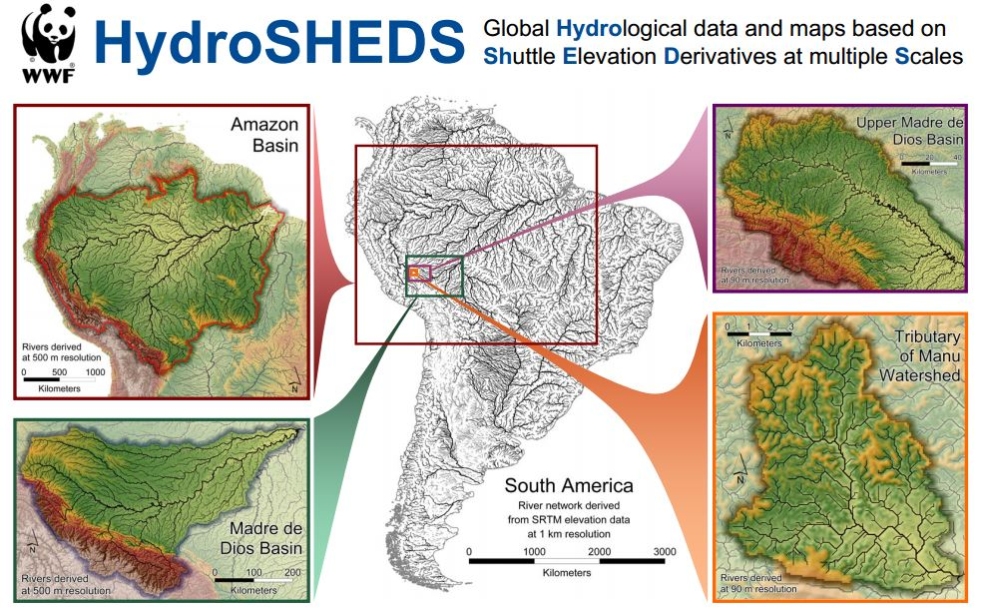

Figure 1: An example of the nested catchments in HydroBASINS

The figure below outlines catchments by HydroBASIN level 6 (grey lines), on top of a water risk layer.
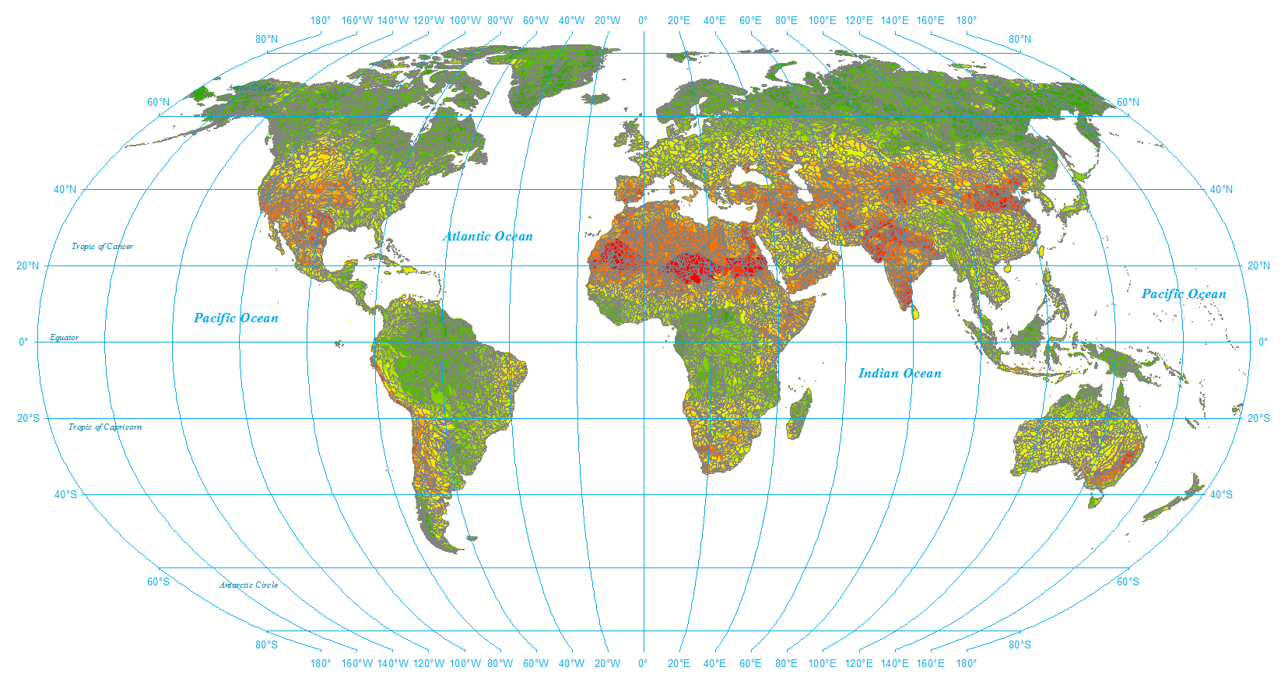

Figure 2: HydroBASIN Level 6 map of the world
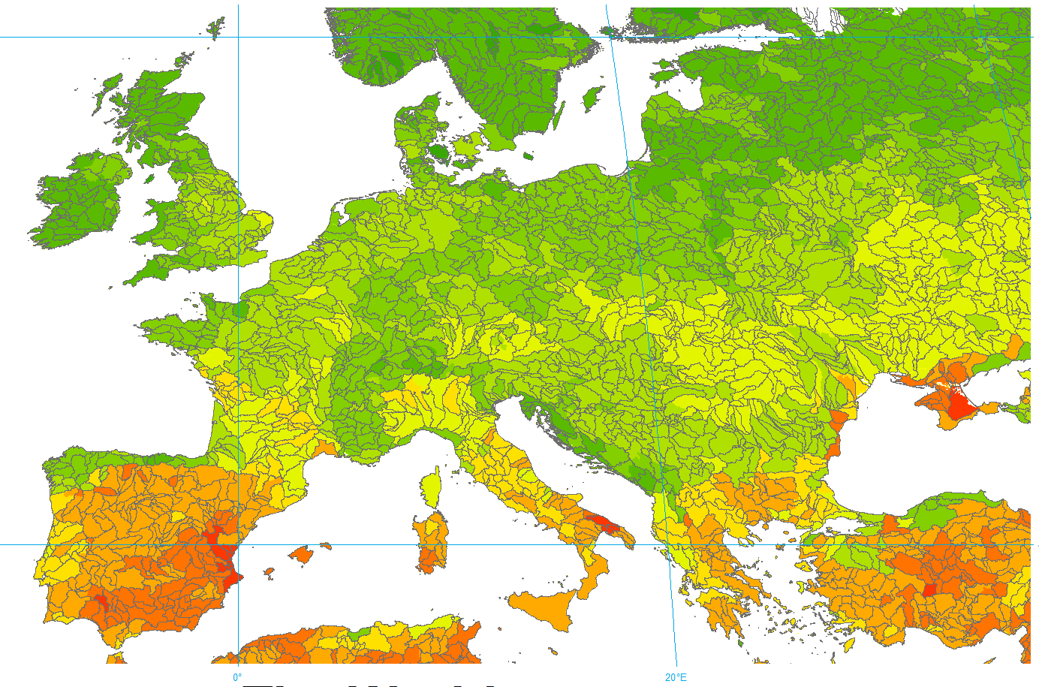
Figure 3: HydroBASIN Level 7 for Europe

APPENDIX 3: RESOURCES FOR STAKEHOLDER ENGAGEMENT
This appendix gives a summary resources for stakeholder engagement.

Resource Description | Objective | Examples
Getting in Step: Engaging and Involving Stakeholders in Your Watershed (US EPA 2013)¹ | The purpose of this guide is to provide the tools needed to effectively engage stakeholder groups and use such groups to communicate with others to restore and maintain healthy environmental conditions through community support and cooperative action. | Guidance for identifying stakeholders and involving stakeholders during the watershed planning process.
Guide to Collective Action (CEO Water Mandate 2013)² | The objective is to provide a stepwise approach to collective action. | Guidance for identifying prospective interested participants, and ways to design a collective action project. The levels of engagement are informative, consultative, collaborative, and integrative.
Guide to Responsible Business Engagement with Water Policy (CEO Water Mandate 2010)³ | The goal of this guide is to make a compelling case for responsible water policy engagement and to support it with insights, strategies, and tactics needed to do so effectively. | Provides principles for effective water policy engagement for the private sector including 1) advance sustainable water management, 2) respect public and private roles, 3) strive for inclusiveness and partnerships, 4) be pragmatic and consider integrated engagement, and 5) be accountable and transparent.
Understanding Public-Private Partnerships (United Nations 2003)⁴ | Discusses public and private sector partnerships and what it takes to make them successful. | Provides examples of different types of public and private partnerships including operational, policy and strategy, advocacy, and multifaceted.
¹ U.S. Environmental Protection Agency. 2013. Getting in Step: Engaging and Involving Stakeholders in Your Watershed. http://cfpub.epa.gov/npstbx/files/stakeholderguide.pdf
² CEO Water Mandate. Guide to Collective Action. 2013. https://ceowatermandate.org/collectiveaction
³ CEO Water Mandate. 2010. Guide to Responsible Business Engagement with Water Policy. https://ceowatermandate.org/policyengagement/
⁴ United Nations. Understanding Public-Private Partnerships. 2003. http://www.globalproblems-globalsolutions-files.org/unf_website/PDF/understand_public_private_partner.pdf

APPENDIX 4: RESOURCES TO UNDERSTAND A CATCHMENT’S WATER CHALLENGES
This appendix gives a summary resources for understanding the catchment’s water challenges.

This stop-light system was developed for this guide and may be used for a first pass high level assessment of the shared water challenges.

 | Severe  Water Challenges | Moderate  Water Challenges | No Water Challenge
Access to Water, Sanitation and Hygiene
Community access to:  - Safe and affordable drinking water*  - Adequate and equitable sanitation and hygiene* | Significant portion of the local population without access to drinking water and/or sanitation and hygiene. | Portion of the local population without access to drinking water and/or sanitation and hygiene. | All the local population with access to drinking water and/or sanitation and hygiene.
Water quality
Quality of surface and groundwater in the basin  (Includes consideration of bacteria, nutrients, harmful substances such as chemicals, turbidity and temperature) | Water bodies are not meeting their intended uses (swimmable, fishable, drinkable) due to serious water quality concerns. Regular violations of applicable water quality permits. | Growing concerns about the safety of the water bodies for their intended uses (swimming, fishing, drinking) with one or more water quality parameters worsening over time. There are some violations of applicable water quality permits. | No concerns about water quality in the basin’s surface and groundwater. No applicable water quality permits are in violation.
Water quantity
Sustainable withdrawals and supply of surface and groundwater | High or extremely high level of surface and/or groundwater stress. | Medium to high levels of surface and/or groundwater stress. | Water withdrawals are in line with renewable supplies of surface and groundwater resources.
Water governance
Performance of water supply and treatment infrastructure | Business and/or local community regularly experience intermittent supply of water and / or inadequate treatment of wastewater. | Occasional minor-moderate level performance issues experienced with water supply and/or treatment. | Water provision to a high standard with full collection and treatment of wastewater.
Existence and enforcement of water policy and regulations* | Water policy and regulations exist, although not based on principles of equity or sustainability nor enforced. | Adequate – effective water policy and regulations in place with inconsistent enforcement. | Effective and equitable water resource policy and regulation in place and being enforced.
Important water related ecosystems
Health of important water related areas** | Water body of high value significantly impaired. No appropriate management interventions defined or being implemented. | High value water area(s) somewhat impaired or threatened, management practices defined to improve or manage its condition although implementation inconsistent. | High value water area(s) in very good condition with management measures in place to protect its status.
Extreme Weather Events
Local capacity to respond to and address water crises* | No mechanism to limit or prioritize allocations during times of drought or to manage extreme flows. | Existence of a mechanism to limit or prioritize allocations during times of crises (floods, droughts), although its effectiveness yet to be proven. | Effective water crisis management. Existence of a proven mechanism to limit or prioritize allocations during times of crises. Where relevant, floodwater hazard mapping, control plans and early warning systems also in existence and proven.

*Denotes data set available via existing tool or standalone data set.
** Important water related areas / ecosystems may include (refer also to Section 4.4, Alliance for Water Stewardship standard): High Conservation Value Areas (e.g., wetlands, riparian vegetation), as well as water-related areas that are of importance to indigenous peoples (e.g., traditional fishing grounds, culturally significant areas).

The WWF Water Risk Filter uses thirty-two basin indicators broken into twelve risk categories to evaluate basin (or catchment) risk, along with higher resolution data sets for twelve select countries. The Water Risk Filter uses a set of operational water risk questions to evaluate company risk. The twelve basin risk categories broadly align with the six different water challenges. The Water Risk Filter has recently added respond section that helps to offer up a set of recommendations derived from context. Such an assessment, combined with recommendations, can help inform a contextual water target.

WRI Aqueduct Water Risk Atlas informs an initial basin assessment. It has eleven indicators grouped into three categories of physical, regulatory, and reputational risk. WRI Aqueduct Flood is a separate and unique tool that provides an additional layer capturing urban damage, affected GDF, and affected population which informs on extreme weather.

UNEP-DHI’s Water Indicator Builder provides useful indicators across all water related challenges.

UNDP’s Use Approach on Assessing Water Governance, OECD’s Water Governance Initiative, Integrated Water Resources Management website, and the World Resource’s Institute and MIT Sloan’s Sustainability Initiative provides useful frameworks and indicators to assess water governance.,,

APPENDIX 5: RIVER BASIN CASED STUDIES TO DETERMINE THE END STATE AND ANALYSE THE GAP
This appendix provides river basin case studies to in which stakeholders determined the current and desired end state and the gap.

Mississippi / Atchafalaya River Basin: One example of setting a desired end state, and developing a plan based on this end state, is the Gulf Hypoxia Action Plan. This plan was created at the request of the federal government to address the water quality challenge of excess nutrients in the Mississippi River Basin and the related hypoxic ‘dead zone’ in the Gulf of Mexico. A task force was created to develop a plan to address this challenge, including agreeing on a shared ‘end state’ for the basin. The desired end state for the Mississippi / Atchafalaya River Basin and Gulf of Mexico is comprised of three components: 1) a reduction in size (by surface area) of the Gulf of Mexico hypoxic zone (coastal goal), 2) restored lands and waters within the basin with a focus on human health and aquatic life (basin goal), and 3) improved communities and economic conditions across the basin (quality of life). The difference between the current state of the basin and this future end state (the ‘gap’) provided a basis for establishing goals for reduction in nutrient loading from across the river basin, which formed the foundation of an action plan. See the Action Plan for more information about this process and the actions that have taken place as a result of the plan.

Total Maximum Daily Load: Another set of examples that could be useful in understanding this process of establishing a desired end state and using it as a foundation for setting targets is the Total Maximum Daily Load planning process. Under the United States Clean Water Act, when a waterway is found to be ‘impaired’, or does not meet certain water quality standards, a process may be set into motion to establish the total allowable load of a specific pollutant to that waterway. The desired end state here is for the waterway to meet the established water quality standard, for example for the water body to become ‘swimmable and fishable’. The desired end state is quantified by the maximum daily loading of the pollutant to the water body that would allow the water body to meet this standard. The gap assessment between the current loading and the total maximum daily load provides a quantitative indication of how much the total loading needs to be reduced to meet water quality standard. This difference (the ‘delta’) forms the basis for action, in terms of specific reductions in loading for actors in the basin who contribute to the pollutant load.

California Groundwater Management: In the midst of extreme drought in 2014, California passed a groundwater management law that requires all medium and high priority groundwater basins (as determined by the state) to develop and implement a sustainable groundwater management plan. In this case the desired end state for the state, and water users in each basin, is sustainable groundwater use in each of these groundwater basins, defined by the avoidance of six “undesirable results.” The gap between current annual groundwater use and a sustainable level of annual groundwater use is the volume by which the water users accessing the aquifer must reduce their total use. This ‘gap serves as a starting point for development of an allocation and action plan for moving the groundwater basin into compliance with the groundwater management act.

Murray-Darling Basin’s Water Resource Plans: Over the years, the combination and natural droughts and increasing water us by agriculture, manufacturing, and communities, has led to the decline in the health of the Murray-Darling Basin. In 2012, a newly-developed basin plan sets new rules, calling for sustainable diversion limits on how much water can be taken from the basin by town, communities, farmers, and industries, while leaving enough water to sustainable natural ecosystems. Given that water use varies over the year, the basin plan focuses on trends over time as well as individual water years. The water use growth over time by different water users will be compared to the water allocations of the basin (https://www.mdba.gov.au/basin-plan-roll-out/basin-wide-compliance-review/sustainable-diversion-limit-reporting-compliance)

APPENDIX 6: EXAMPLE SITE-LEVEL WATER TARGETS
This appendix provides additional site-level water targets for water governance.

Water Governance Goals
Desired End State, | Example Goals | Illustrative Internal Actions to Meet Goal
Effective water resource management policy and regulation | Advocate for and contribute to the development of effective and equitable water policy and regulations. | - Completion of an internal review of the effectiveness of National and Sub-regional water policy and regulation.  - Establish and execute an advocacy plan for effective water governance, and policy development and implementation in line with accepted principles.
Coherent policies with effective government coordination | Support government in developing and executing a plan to ensure alignment across departments / authorities and policy on water. | - Completion of an internal, cross-functional evaluation of external policy coherence in respect to water.  - Internal training of staff that deal with government representatives to ensure aligned messages on water and land management issues.
Robust basin management plans | Active role in catalyzing and contributing to a revision of the Catchment Management Plan to ensure it is current and informs robust water resource planning and management. | - Publicly support proposals to evaluate and update Catchment Management Plans to ensure it is current.  - Provision of relevant company held data and information to relevant authorities.  - Providing input or feedback to the development or revision of a catchment plan  - Actively participate in Catchment management planning workshops and the like.
Strong basin institutions | Work with others to support the measurable improvement in institutional capacity of catchment authority / organisations. | - Support training of water authority staff in current water monitoring techniques.  - Lend in-kind support for water authority planning exercises  - Catalyse the formation of an active cross sector catchment working group.
Formalised public participation | - Support formalised public participation in water resource management/governance oversight and/or decision-making. | - Participatory water monitoring program with local community stakeholders established.  - Convene open public events to advance awareness and understanding of local water issues.  - Reformat site water use data and information so more accessible to local stakeholders.
Robust data and information for informed decision-making | - Collaborate with others to establish joint water-related data collection programs.  - Advocate for and support through collaboration the successful establishment of a consistent data and information system across sectors. | - Publish site water monitoring date online to be freely accessible to all.  - Co-convene water data workshop with other industry sectors in the catchment.
Ongoing monitoring and evaluation of water resources | - Contribute to the expansion of the public groundwater monitoring program. | Water authority staff trained in current water monitoring techniques.
Quality infrastructure - water provision and treatment | - Work with communities to improve access to water services  - Water infrastructure and service improvement plans developed / being advanced by the Government. | - Sharing of water infrastructure to optimise outcomes including access to other water users.  - Support programs and investments focused on community access to clean water, hygiene and sanitation.  - Aid environmentally and socially responsible infrastructure development  - Contribute to government led water infrastructure and service improvement planning exercises.
Effective water crisis management | Support the local authority undertake a Comprehensive risk (hazard and vulnerability) assessment with stakeholder input that results in the development of a Disaster Response Plan that is made publicly available. | - Establish on-site flood control measures that protects on-site and downstream assets.  - Support establishment of early warning systems for community and industry.  - Commission the development of hazard zonation maps and make publicly available.

ACKNOWLEDGEMENTS

Project Partners
The guidance was written by the project team:

CDP
Christina Copeland
Cate Lamb

CEO Water Mandate
Tien Shiao
Ross Hamilton
Cora Kammeyer
Jason Morrison

The Nature Conservancy
Kari Virgerstol
Naabia Ofusu-Amaah

World Resources Institute
Paul Reig

World Wide Fund for Nature
Alexis Morgan
Rylan Dobson

UNEP-DHI Partnership
Peter Bjornson

The guide was edited by (TBD) and designed by (TBD).

External experts
The following external experts provided advice on substance and structure throughout the guidance’s development: TBD

The enterprise-level water targets guide is currently in development and is meant to complement the site-level water targets guide but focus on setting targets across a portfolio of locations distributed within a company’s value chain. The site-level water targets set targets for a few site locations in a catchment and the enterprise-level water targets guide helps companies aggregate site-level targets.
World Economic Forum. 2019. The Global Risks Report 2019, 14th ed. http://www3.weforum.org/docs/WEF_Global_Risks_Report_2019.pdf
United Nations. 2018. Sustainable Development Goal 6 Synthesis Report on Water and Sanitation. http://www.unwater.org/publication_categories/sdg-6-synthesis-report-2018-on-water-and-sanitation/
United Nations Facts on Water Quality and Wastewater. http://www.unwater.org/water-facts/quality-and-wastewater/
OECD. 2012. OECD Environmental Outlook to 2050. https://www.oecd.org/g20/topics/energy-environment-green-growth/oecdenvironmentaloutlookto2050theconsequencesofinaction.htm
Water Governance Facility’s Overview of Water Governance Challenges. http://www.watergovernance.org/governance/challenge/
WWF. 2018. Living Planet Report - 2018: Aiming Higher, 12th ed. https://wwf.panda.org/knowledge_hub/all_publications/living_planet_report_2018/
See UN Water website for facts on climate change and water related disasters. http://www.unwater.org/water-facts/climate-change/, http://www.unwater.org/water-facts/disasters/
Lloyd’s. 2010. Lloyd’s 360° Risk Insight: Global water scarcity: risks and challenges for business. http://awsassets.panda.org/downloads/lloyds_global_water_scarcity.pdf
ICMM. 2015. A practical guide to catchment-based water management for the mining and metals industry. https://www.icmm.com/website/publications/pdfs/water/practical-guide-catchment-based-water-management_en
BIER. 2015. Insights and Opportunities: Performance in a Watershed Context. https://www.bieroundtable.com/news/evaluating-facility-water-stewardship-performance-in-context-of-local-watershed-conditions/
The UN Sustainable Development Goal website provides information on each of the 17 Goals including associated targets and indicators. https://www.un.org/sustainabledevelopment/sustainable-development-goals/
AWS. 2019. The AWS International Water Stewardship Standard v2.0. https://a4ws.org/the-aws-standard-2-0/
Steffen,W.; Richardson, K.; Rockström, J.; Cornell, S.E.; Fetzer, I.; Bennett, E.M.; Biggs, R.; Carpenter, S.R.; de Vries, W.; de Wit, C.A.; Folke, C.; Gerten, D.; Heinke, J.; Mace, G.M.; Persson, L.M.; Ramanathan, V.; Reyers, B. and S. Sörlin.2015. Planetary boundaries: Guiding human development on a changing planet. Science, 347 (6223): 736–746. https://science.sciencemag.org/content/sci/347/6223/1259855.full.pdf
CEO Water Mandate. 2013. Guide to Water-Related Collective Action. https://ceowatermandate.org/wp-content/uploads/2013/09/guide-to-water-related-ca-web-091213.pdf
AWS. 2019. The AWS International Water Stewardship Standard v2.0. https://a4ws.org/the-aws-standard-2-0/
For example, the Water Risk Filter, is a tool developed by WWF to evaluate a company’s water risk across their facilities, employing both a qualitative and a quantitative approach to calculate the operational water risk.
AWS. 2019. The AWS International Water Stewardship Standard v2.0. https://a4ws.org/the-aws-standard-2-0/
See RAMSAR Convention on Wetlands website for listings of wetlands of international importance. https://www.ramsar.org/
See IUCN website for the Red List of Threatened Animal and Plant Species. https://www.iucnredlist.org/
Global models, which are incorporated into tools such as Aqueduct and the Water Risk Filter and, are intended for larger basins and are often not as accurate as validated, local data. For example, WaterGAP, one of the key global hydrological models, is reasonably calibrated to HydroBASIN Level 6 or 7 (see Appendix 2) but is not suitable for application at scales finer than this.
ICMM. 2015. A practical guide to catchment-based water management for the mining and metals industry. http://www.icmm.com/website/publications/pdfs/water/practical-guide-catchment-based-water-management_en
CEO Water Mandate. Water Action Hub. https://wateractionhub.org/
HydroSHEDS database. https://hydrosheds.org/
Examples of HydroBASIN size. https://opendevelopmentmekong.net/maps/rivers-and-hydrobasins/.
WWF. Water Risk Filter. http://waterriskfilter.panda.org
WRI. Aqueduct. www.wri.org/aqueduct
WRI. Flood Risk Analyzer. https://floods.wri.org/
UNEP-DHI. Water Indicator Builder. www.waterindicator.com/builder
OECD. Water Governance Indicators and Frameworks. https://www.oecd.org/cfe/regional-policy/Inventory_Indicators.pdf
Integrated Water Resources Management website. http://iwrmdataportal.unepdhi.org/iwrmmonitoring.html
World Resources Institute and MIT Sloan Sustainability Initiative. 2018. Mapping Public Water Management by Harmonizing and Sharing Corporate Water Risk Information. https://www.wri.org/our-work/project/water-management
Mississippi River/Gulf of Mexico Watershed Nutrient Task Force. 2008. Gulf Hypoxia Action Plan 2008 for Reducing, Mitigating, and Controlling Hypoxia in the Northern Gulf of Mexico and Improving Water Quality in the Mississippi River Basin. https://www.epa.gov/sites/production/files/2015-03/documents/2008_8_28_msbasin_ghap2008_update082608.pdf
Rogers, P. and A. Hall. 2002. Effective Water Governance. GWP. https://www.gwp.org/globalassets/global/toolbox/publications/background-papers/07-effective-water-governance-2003-english.pdf
Araral B.E., and D. Yu. 2010. Asia Water Governance Index. Singapore: Lee Kuan Yew School of Public Policy, Institute of Water Policy. https://lkyspp.nus.edu.sg/iwp/wp-content/uploads/sites/3/2013/04/AWGI-brochure-IWP-LKYSPP9-10.pdf
OECD. 2018. Implementing the OECD Principles in Water Governance: Indicator Framework and Evolving Practices. http://dx.doi.org/10.1787/9789264292659-en

